17. Section 4 Introduction

1. Git stores four kinds of objects in repo.
   1. BLOB.
   2. Tree.
   3. Commit.
   4. Annotated Text.

PDF - How Git works under the hood

[4. How Git works under the hood (stashchuk.com)](https://stashchuk.com/static/git/4-how-git-works-under-the-hood.pdf)

19. Initialize new Git Repository

1. git init:
   1. To initialize **empty repo** even though directory may be not initialized.
   2. .git hidden folder will be created.
   3. .git is local git repo.
2. ls -la : To display hidden folders.
3. Bash Shell vs Git Bash

|  |  |
| --- | --- |
| Bash Shell | Git Bash |
| Doesn’t show if current dir is under git control. |  |
| Doesn’t show the current branch. |  |

20. Overview of .git folder

1. Command: start . or explorer .
2. under .git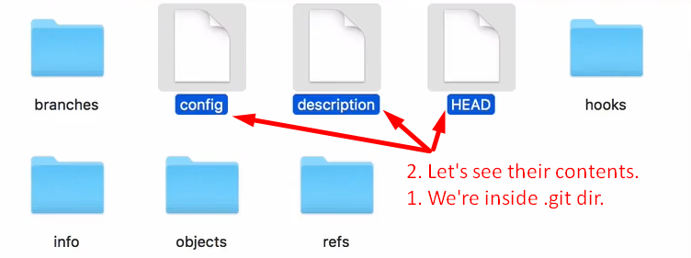  
   above, git has its own **file system**.  
   Objects directory stores git objects (BLOB, Tree, Commit, Annotated Text)

21. Git object Types

1. Those four objects are used to track files and changes in the files.
   * 1. **Blob**: Any kind of file is stored as blob.
     2. **Tree**: To store directory info. Dir maybe empty or contain other files and/or directories.
        1. Tree is set of blobs (files) and/or other trees (dirs)
     3. **Commit**: This object is used to store different versions of our project.
     4. **Annotated Tag:** Text pointer to other commits.
2. Low level commands:
   1. **git hash-object**: To create git object only BLOB.
   2. **git cat-file**: To read git object.

22. Writing new git object with hash-object.

1. 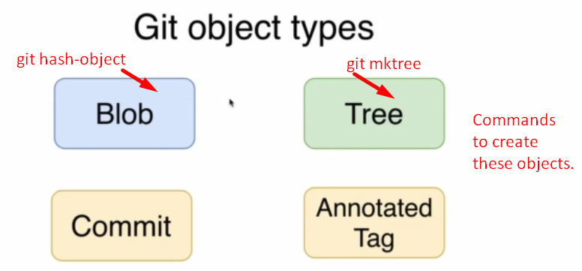
2. 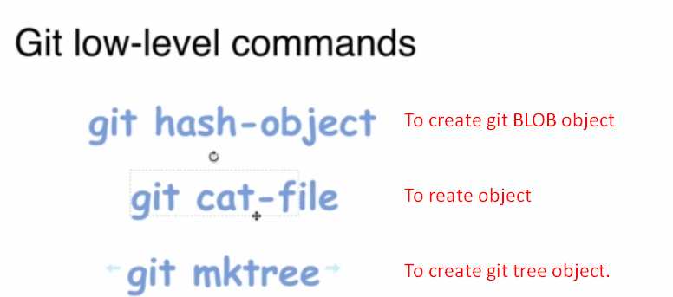
3. d

|  |  |  |  |  |  |
| --- | --- | --- | --- | --- | --- |
| Linux Command | input: All formats allowed |  | git command | Input source | To save object under .git/objects |
| echo | “Hello, Git” | | | git hash-object | --stdio | -w |
|  | ‘Hello, Git’ |  |  |  |  |
|  | Hello, Git |  |  |  |  |

Let’s assume the hash for the BLOB 🡺 **b7**aec520dec0a7516c18eb4c68b64ae1eb9b5a5e  
output: 

hash = Folder Name + File Name.

23. JSON vs Git database

1. Git DB Structure similar to JSON.
   1. **Key**: The hash of the file.
   2. **Value**: The file itself.  
      But in Git, even can not be duplicated as key is calculated based on file’s content.   
      If file content is same then same key will be achieved.
2. Hash = Folder Name + File Name.

24. What is hash function

1. We know that based on file’s content, hash code is generated and then the generated blob is stored under .git/objects creating a new folder whose name is first 2 characters of the hash code and blob is stored inside this folder and its name is the remaining hash characters.  
   file content 🡪 hash-function() 🡪 BLOB 🡪 Folder
2. Always Fixed Length Hash.
3. Hash functions are “One-Way” function.
4. Same hash function will create same hash code for the same input.

25. Hash functions overview

1. 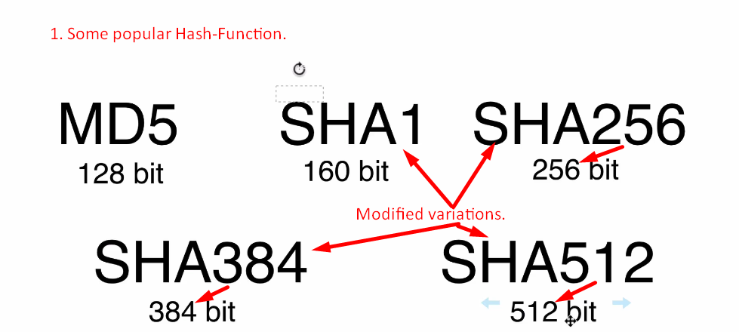
2. Variable Length input but Fixed length Hash.

25. SHA1 Hash Function

1. SHA1: 160Bit = 40 Hexadecimal Characters, hash Function or algo.
2. **Commands**: